**Report of Swa Roopwardhinee NGO Volunteering**

**Name: Atharva Digambar**

**Duration: 08 March 2025 – 08 April 2025**

**Total Hours: 75 Hours**

* **Overview**Engaging with the NGO Swa Roopwardhinee provided us with a chance to participate in several meaningful community-driven efforts. Over a span of one month, I contributed 75 hours through a blend of educational and community service activities.

1. **Playing and Engaging with Children  
   *Time Dedicated: 10 Hours***We organized outdoor games like cricket and football and indoor sessions such as chess and carrom. These interactions helped the children unwind, build coordination, and boost their self-esteem.

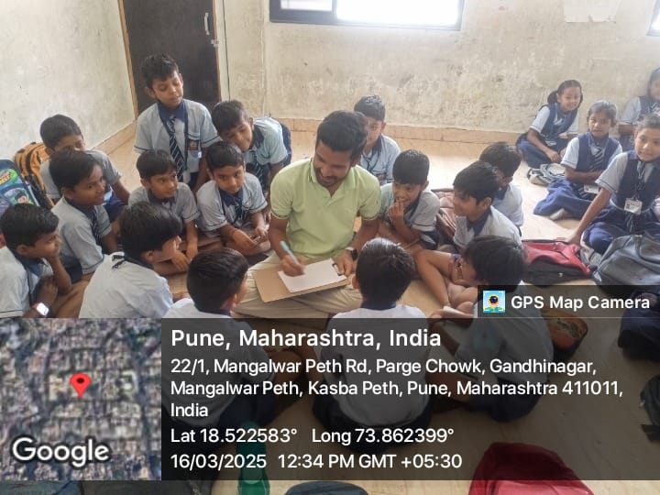

1. **Community Hygiene Campaigns  
   *Time Dedicated: 20 Hours***We conducted sanitation drives to spread awareness about cleanliness. Our team used visuals, plays, and interactions to engage the community effectively.

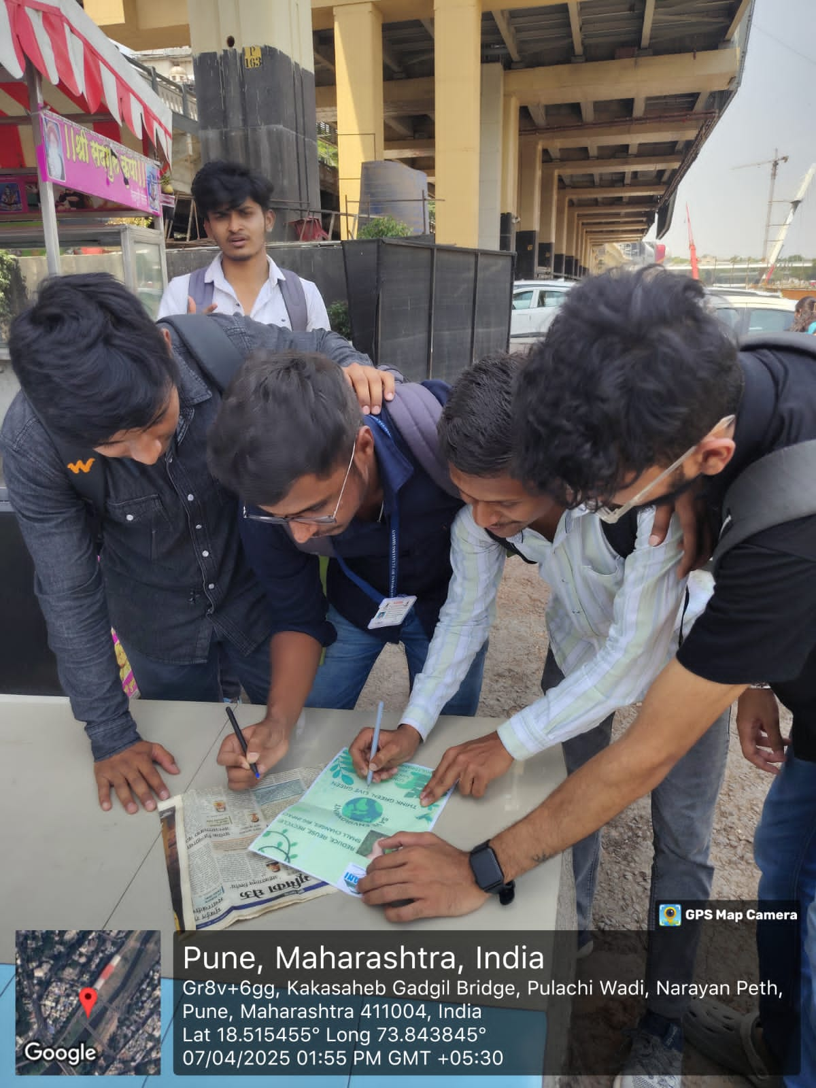

1. **Educational Sessions  
   *Time Dedicated: 20 Hours***Academic reinforcement sessions were held for children from disadvantaged backgrounds. These sessions were aimed at basic numeracy, literacy, and communication skills improvement.



**4. Tree Planting Initiative  
*Time Dedicated: 15 Hours***We planted trees and explained their environmental impact to the children. This activity emphasized the role of greenery in combating climate change.

**5. Animal and Community Welfare  
*Time Dedicated: 10 Hours***As part of our humane efforts, we provided food to stray dogs and the needy, contributing to a more caring and inclusive society.

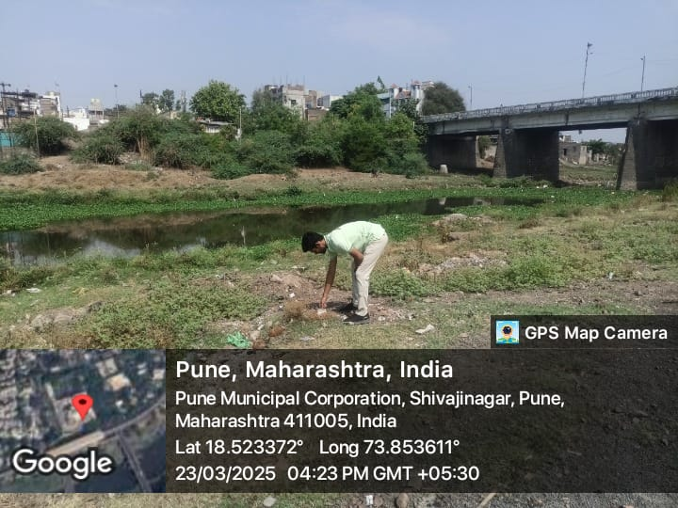

**Conclusion**The journey with Swa Roopwardhinee was fulfilling and enlightening. It has strengthened my resolve to continue contributing toward positive societal change. I thank the organization for giving us this enriching platform.